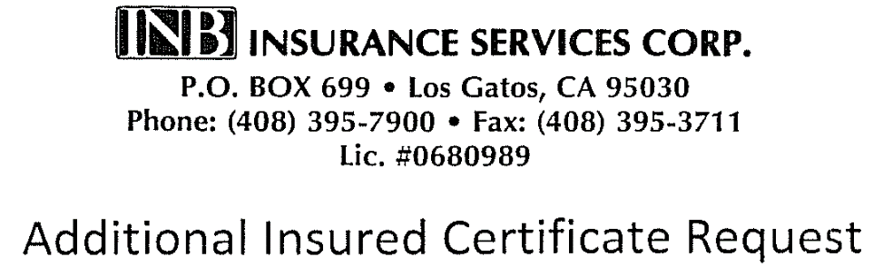

Submitted through:
Central California Fellowship
9960 Business Park Dr. #110 Sacramento, CA 95827-1719
Office: (916) 454-1771
Email: centraloffice@aasacramento.org
Fax: (916) 452-9132

Insured: Central California Fellowship of Alcoholics Anonymous
Policy Number: 201632661 NPO

Please complete ALL questions. This request form does not automatically bind coverage for the additional insured being requested.
Applications for this policy period must be submitted by March 30, 2020

- Name (as it must legally appear on the Certificate) and address of landlord.

- Landlord’s contact person:
Name: _______________________________________________________________________
Phone: ___________________________________________________________________
Email: ____________________________________________________________________
Fax: ______________________________________________________________________

- A.A. Group/Meeting information:
Group Name: ____________________________________________________________ Address: ________________________________________________________ Contact Name: __________________________________________________________
Please keep a current name on file with Central Office at all times.
Contact Address: ________________________________________________________ Contact Phone: __________________________________________________________ Contact Email: ___________________________________________________________

- Number of meetings per week at this location:

Please deliver this application to CENTRAL OFFICE, together with the premium due. We will submit the application and a Certificate will be sent directly to your landlord, with a copy to Central Office. We cannot submit your application without full payment of the premium due; sorry – no exceptions.

DO NOT DELIVER THIS APPLICATION TO THE INSURANCE COMPANY OR ITS AGENT DIRECTLY;

NO CERTIFICATE WILL BE ISSUED.

