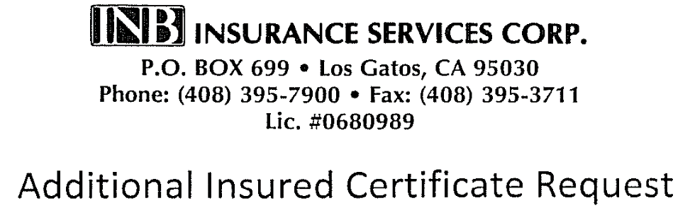

2021 Special Event Insurance Application

Submitted through:
Central California Fellowship
9960 Business Park Dr. #110 Sacramento, CA 95827-1719
Office: (916) 454-1771
Email: centraloffice@aasacramento.org
Fax: (916) 452-9132

Insured: Central California Fellowship of Alcoholics Anonymous
Policy Number: 201632661 NPO

Please complete ALL questions. This request form does not automatically bind coverage for the additional insured being requested.
Applications for a special event must be submitted 30 days prior to the event. Insurance is $100 per event.

- Name (as it must legally appear on the Certificate) and address of landlord.

- Landlord’s contact person:
Name: _______________________________________________________________________
Phone: ___________________________________________________________________
Email: ____________________________________________________________________
Fax: ______________________________________________________________________

- A.A. Group/Meeting information:
Group Name: ____________________________________________________________ Address: ________________________________________________________ Contact Name: __________________________________________________________
Please keep a current name on file with Central Office at all times.
Contact Address: ________________________________________________________ Contact Phone: __________________________________________________________ Contact Email: ___________________________________________________________

- A.A. Special Event information:
Event Name: _________________________________________________
Event Date/Time: _____________________________________________
Event Location: _______________________________________________

Please deliver this application to CENTRAL OFFICE, together with the premium due. We will submit the application and a Certificate will be sent directly to your landlord, with a copy to Central Office. We cannot submit your application without full payment of the premium due; sorry – no exceptions.

DO NOT DELIVER THIS APPLICATION TO THE INSURANCE COMPANY OR ITS AGENT DIRECTLY;

NO CERTIFICATE WILL BE ISSUED.

