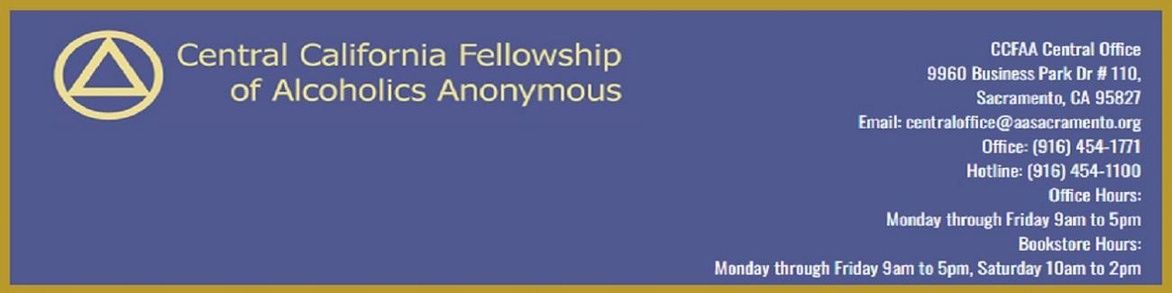
Central California Fellowship of A.A. - 2023 Survey
We would like your opinion and hope your Fellowship, Group, or Meeting would take the time to express it. The following are some general questions that can help us Central California Fellowship of A.A. (CCFAA) serve you better. This should only take a few minutes---perhaps at your next business meeting, this can be done. We would like to hear from you by March 31, 2023. We will publish our findings as soon as possible after May 1st, 2023. Please only one submission per Fellowship, Group, or Meeting.
Thanks for your interest in our Central California Fellowship of A.A. (CCFAA) and for taking the time to complete this survey.
- Group Name: ____________________________
- Group Representative Name: ______________________________
- We may need to follow up on some items. If you are comfortable providing, what is your best Group email?
______________________________
- Does your group know where the CCFAA office is located?
Yes ☐ No ☐
- Has anyone from your group visited the CCFAA office in the past year?
Yes ☐ No ☐
- Does your group know that CCFAA provides services such as discounted Group Insurance, Flyer Mailings, Annual Picnics, and Speaker Events?
Yes ☐ No ☐
- Do you believe the CCFAA serves all Groups in the Greater Sacramento Area of diverse backgrounds?
Yes ☐ No ☐
If you just responded that your group believes the CCFAA does NOT serve all Groups in the Greater Sacramento Area of diverse backgrounds.
We very much appreciate your comments.
Would you kindly offer up a comment of any length that we may use as constructive feedback?
__________________________________________________________________
__________________________________________________________________
__________________________________________________________________
__________________________________________________________________
__________________________________________________________________
__________________________________________________________________
- Would your group like to have more information on how to get involved with CCFAA?
Yes ☐ No ☐
- Does your group send a representative to the monthly Delegates’ meeting?
Yes ☐ No ☐
If you responded that your group does send Representatives to the CCF Delegates Meeting, would you please confirm their contact Name & Email information?
__________________________________________________________________
__________________________________________________________________
- Does your group know that CCFAA has a website? https://aasacramento.org/
Yes ☐ No ☐
- Has anyone from your group used the 12-step meeting guide on the CCFAA website? https://aasacramento.org/meetings/
Yes ☐ No ☐
- Has anyone from your group ordered literature online through the CCFAA’s webstore? https://aasacramento.org/store/
Yes ☐ No ☐
- Does your group know that our Book Store is open on Saturdays 10am to 2pm?
Yes ☐ No ☐
- Does your group encourage its members to volunteer for service commitments with CCFAA?
(Example: Picnic, help in office, take 12-step calls, phone service, hotline etc.)
Yes ☐ No ☐
- Has anyone in your group ever called our AA Hotline for help or information at (916) 454-1100?

Yes ☐ No ☐
- Are our volunteers at the office doing a good job answering the CCFAA phones at (916) 454-1771?
Yes ☐ No ☐
If you just responded that your group believes the CCFAA does NOT do a good job answering the phones.
We very much appreciate your comments.
Would you kindly offer up a comment of any length that we may use as constructive feedback?
__________________________________________________________________
__________________________________________________________________
__________________________________________________________________
- Is your group receiving its copy of our monthly newsletter, By the Way?
Yes ☐ No ☐
- Does your group feel the CCFAA is fulfilling its purpose, to aid the AA groups in the greater Sacramento area to carry the message of Alcoholics Anonymous?
Yes ☐ No ☐
You may have responded that your group believes the CCFAA does NOT do a good job fulfilling its purpose.
We very much appreciate your comments.
Would you kindly offer up a comment of any length that we can use as constructive feedback?
__________________________________________________________________
__________________________________________________________________
__________________________________________________________________

- Would your group like to have more information on how to get involved with CCFAA?
Yes ☐ No ☐
- You may have previously responded that you'd like to learn more about CCFAA.
Please take a moment and choose what areas to which we can provide additional information.
☐ More information on how to - Get involved with our CCFAA Intergroup

☐ More information on how to - Send a representative to monthly CCFAA Delegate Meetings.
☐ More information on how to - Encourage members to volunteer for service commitments
with CCFAA? (12-step calls, phone service, etc.)
☐ Yes, we'd like a copy of our monthly newsletter, By the Way.
- How can Central Office improve its current services?
__________________________________________________________________
__________________________________________________________________
__________________________________________________________________
__________________________________________________________________
- What services would you like to see Central Office include?
__________________________________________________________________
__________________________________________________________________
__________________________________________________________________
__________________________________________________________________
- So that CCFAA can follow up with your information request, what is the best Group contact email?
__________________________________________________________________
__________________________________________________________________
__________________________________________________________________
__________________________________________________________________
Thanks for helping our Central California Fellowship serve you more effectively.
Please complete and return to:
CCFAA Central Office
9960 Business Park Dr # 110, Sacramento, CA 95827 https://aasacramento.org
Email: centraloffice@aasacramento.org
Office: (916) 454-1771
Hotline: (916) 454-1100
Office Hours: Monday through Friday 9am to 5pm
Bookstore Hours: Monday through Friday 9am to 5pm
Saturday 10am to 2pm

