- Opening – February 17, 2024
A. Call to order at 3:00 pm | B. Open with Serenity Prayer | C. 12 Traditions read by - Jacob O.
D.CCFAA Preamble read by - Alie T. | E. 7th Tradition - Laura B. | F. Delegate Check-in/Group Announcements
- Preliminary Business:
Delegate Check-in: Total Delegates= 60 Quorum met: YES
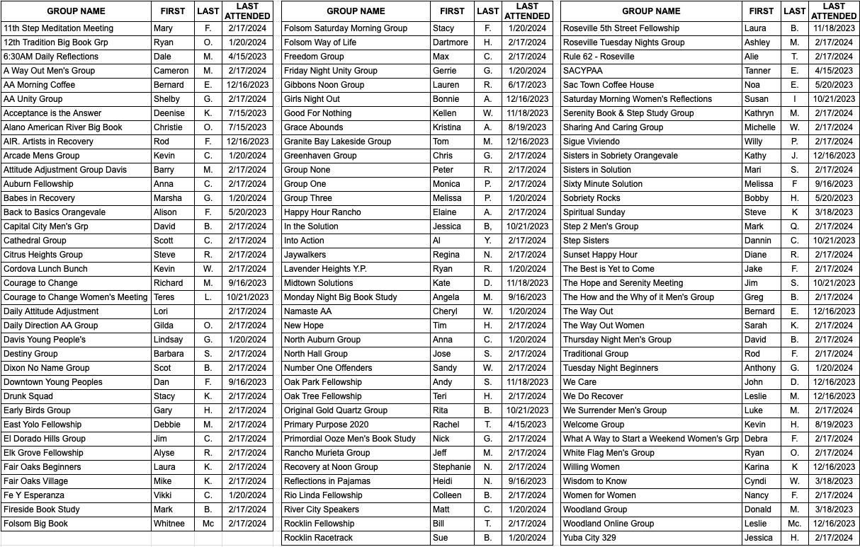
Board of Directors:
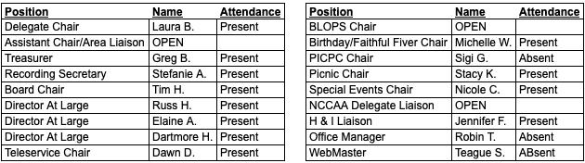

New Delegates:
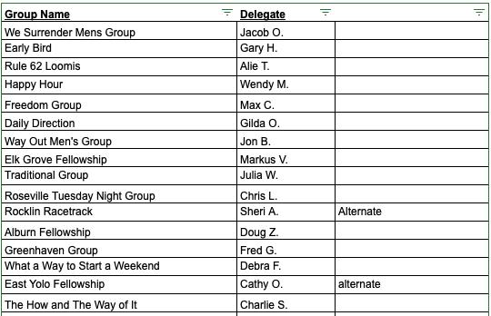
Welcome new delegates!!

Sobriety Birthdays - A total of 68 years! HAPPY BIRTHDAY!

- Approval of Minutes
January 20, 2024 minutes reviewed by Laura B. (Delegate Chair), motion introduced by Tim H., Dawn D. (2nd the motion) -
passed unanimously.

- Trusted Servant Reports
- Delegate Chair’s Report – Laura B.
One month into the new year of service, I want to welcome all new and returning delegates. This is a new and exciting service position for many of you! Questions about the specifics of your role and your responsibilities in that role, can be addressed each month in the 2:30 orientation right before the Delegates meeting at 3:00 pm.

Every delegate is encouraged to come a little early and attend the orientation, especially those delegates who have not attended in a while, for a “refresher.” I want to invite every delegate, new and returning, to take an active role by joining committees, and with lively participation in discussions.

In this meeting we will be hearing the report from the Special Audit Committee. They completed their audit ahead of schedule this year and presented their findings to you. Very big thanks to all of the Special Audit Committee members for their generous service; Mary F., Sue B., and Whitnee M.; and to our Treasurer, Greg B. for his wisdom and guidance, and especially to our Superhero Office Manager, Robin T.

For old business this month, we will be discussing any questions the Delegates have brought back from their groups regarding the by-laws change in expenditure approval ceiling presented in our January Delegate Meeting.

I attended the Board of Directors meeting on February 13th. A proposed change to the Prudent Reserve was approved to bring our Central Office into better alliance with generally accepted business operations procedures. We will discuss this matter in new business for the Delegate Body to take to their groups for approval.

In new business we will also be calling for nominations for our three open service positions; Assistant Chairperson/CNIA Liaison; By-laws & Operating Procedures (BLOPS) Chairperson; NCCAA Delegate.

Thank you to every Delegate member for your continued service. CCFAA is YOU. It is all of us. It is every group that has stepped forward to be part of this intergroup effort. Supporting CCFAA is not supporting some other organization or office. It is supporting our own ability to collectively carry the message.
In love and service,
Laura Bishop

- Assistant Chair Report - OPEN
- No report

- Board Chair’s Report – Tim H.
Board meeting was started at 6:00 by Tim H. Board Chair. Roll call was taken and a quorum was established with one board member absent. Motion to accept the minutes for the January 2024 board meeting minutes was made and accepted. Minutes for this meeting will be posted on the CCFAA website in the coming weeks.

In the last week we have received resignation letters from both our Assistant Delegate Chair and our BLOPS Chair and will be discussing this later on in this meeting.

On January 8th the office migrated to QuickBooks Online and it is working well. Our office manager is working diligently to implement some of the tools that QuickBooks online has that will save us money in the future.

On February 1st the office migrated to a new phone system Vonage and it is working well. More Updates to come.
Thank you for allowing me to be of service,
Tim H.

- Treasurer’s Report – Greg B.
Please reference the Statement of Activity Actual vs. Budget January 2024 included in the attachments. Highlighted items reflect information in this report. Thank you to our volunteers, special workers, Office Manager Robin, and staff.

January’s deposits, expenses, payables, and bank reconciliation have been audited. Everything checks out and signed copies are on file at the CCFAA office.
1. Literature sales were strong for the month at $8,478 on a budget of $7,083. [line 4020]
2. Medallion sales were good at $4,092 compared to a $3,125 budget [line 4035].
3. Group Contribution was strong at $18,263, as we budgeted $12,000 [line 4100]. Thanks to all the groups for the contributions to keep the office going for our fellowship.
4. Birthday contributions were good at $256 on a budget of $125 [line 4120]. Get the word out and HAPPY BIRTHDAY!
5. Faithful Fivers income was off slightly at $880, as we budgeted $917 [line4130]. This is a great way for us, as individuals, to directly support CCFAA each month. Sign up today at www.aasacramento.org click on DONATE then FAITHFUL FIVER.
6. Total Income was up for January at $36,211 on a budget of $26,894. [Total Income line]. Most groups make contributions at the end of each quarter. This was the quarter‐end month.
7. Cost‐of‐Goods‐Sold was good, $8,980 with our budget of $82,25, reflecting higher than budget literature and medallion sales. [Total COGS].
8. Payroll Expense was $10,995 in line with the budget amount of $10,998. [Total Payroll Expenses].
9. Insurance Expense of $1,420 was high versus the budget of $475 due to the payment of the annual Workers' Compensation insurance premium. [Total Insurance].
10. Utilities expense was high due to higher than budgeted telephone expenses. This is due to the transition from AT&T to Vonage. The actual amount for the month was $2,287 versus the $1,304 budget. [Total Utilities].
11. Expenses were slightly high at $20,444 compared to the $18,669 budget, primarily due to Insurance and Utilities expenses, as explained above. [Total Expenditures].
12. January’s net income was $6,788 versus a break‐even budget of $0. [Net Revenue]. We, as members of Alcoholics Anonymous, are helping to make great investments in the future of our Central Office. Thanks to each and every one and your groups for that.
Thank you ALL for your support and involvement with CCFAA. Bring a friend.

*Please take the following back to your groups ‐
a) Supporting CCFAA helps bring service to our AA groups and meetings with Literature, Hot Line, Special Events, By The Way Newsletter, Sobriety Chips, and so much more.
b) The NEWLY REMODELED store is open (Open Mon‐Fri 9‐5 and Saturdays 10‐2)
c) Contributions can also be made anytime by Venmo, PayPal, Check, or Cash.
Any question can be directed to my contact information below.
Regards, Greg B. cfo@aasacramento.org

- Business Office Manager’s Report – Robin T.
1. All 4th Quarter payroll and sales tax reports, deposits, and returns were completed by the January 31st due date.
2. Our Workers’ Comp Insurance has been renewed for the period 01-19-2024 to 01-19-2025.
3. The enrollment period for meeting insurance opened on January 15th and will close on March 31st. Please note that you must reapply for insurance each year even if you are currently enrolled in our program. After March 31st only applications for special events coverage, groups who had a policy in 2023, and newly registered groups will be accepted. Any questions, please go to our website: aasacramento.org under the resources tab or call our office Monday-Friday 9am-3pm at 916-454-1771
4. New Invoicing Policy Starting February 1, 2024, a new invoicing policy went into effect for any group that INVOICES literature or medallions through the Central Office. If your group does use this service with the office, we ask that you have a current mailing address, email, and contact person (preferably the treasurer) on file with us. All groups were mailed a copy of the new policy and the request for contact information. If you have any questions, please contact the business office.
5. Special of the Month – Praying Hands Glitter Painted Medallions on Sale $12.95+tax – A wonderful revision to a classic keepsake, this medallion features the timeless symbol of contact with ones’ higher power, the praying hands, featured on a background of blue glitter under a glossy surface. Description: Pewter, 1 5/1 diameter with glitter paint.
Always working together.
- Teleservice Chair’s Report – Dawn D.
____________________________________________________________
Website: http://aasacramento.org/service-opportunities/teleservice/
Shift Call Numbers: January 2024
12 Step = 33/ YTD 33
Info = 156/ YTD 156
Total = 189/YTD 189

New Business:
- TS Shift Coordinators monthly check-in on the 2nd Wednesday of each month.
- New Teleservice phone service, Vonage went live on 2/1/2024. – Jordan A. stepped up to the plate researching and learning the Vonage App to train all the volunteers before going live. As expected, there have been a handful of hick-ups, and he got through them with grace. His passion does not go unnoticed.
- We have 3 Shift Coordinator positions open currently and are looking to fill these positions ASAP. I have 2 Coordinators covering 4 days currently.
- Virtual Workshop for Teleservice Volunteers.
  - Wednesday, April 24 th , 2024, 6-8 PM
  - Please encourage any who are interested and are already a volunteer to join. This is a great opportunity to learn about the new system, hear about the updates to our guidelines, and be a part of an amazing team.

Next CCFAA Holiday Office Closures - Teleservice will cover these day (s):
- Monday 2/20/2024 Presidents Day will be covered

Thank you for letting the Teleservice Team be of service!
Dawn D.

- Webmaster’s Report – Teague S.
New Business:
- None

Old (Open) Business:
- Open Web Priorities:
  - Linode, intermediate site upgrade before final migration to new server
  - Redo PHP back end - Amazon Web Services in progress
  - Reskin Site
  - Form tech committee
Questions please send to webmaster@aasacramento.org

- PI/CPC Chair’s – Sigi G. - Report read by Laura B.
We’ve had a recent uptick in attendees to the PI/CPC monthly business meeting, many offering great ideas for PI/CPC work, but we are still in need of sober alcoholics to volunteer for activities such as 'information table' coverage at events like Spring Fling. Calling for Delegates to invite members of their group interested in service to email Sigi at: picpc@aasacramento.org, and join the next monthly business meeting (details on the CCF website and the By The Way).
- We will have elections at our next business meeting in March. Positions include:
  - PI/CPC Co-Chair
  - Treasurer
  - and others
- We had a recent inquiry regarding Elk Grove Unified School District, and will be exploring how best to support them.
In Service,
Sigi G.

- By Laws & Procedures Chair’s Report – OPEN

- Reports – Special Committees, Delegates, Liaisons & Invited Guests
- Hospitals & Institutions Liaison’s Report – Jennifer F.
All is well with Hospitals and institutions.

There are LOTS of opportunities to be of service through H & I and we have some new facilities with positions that need to be filled. We are in need of some facility coordinators, secretaries and speakers. I have a list of opportunities if you ask me. The Local Jail is speeding up the approval processes in order to help with an influx of individuals with substance abuse issues, so if that is something that interests you, please get in contact with me.

All are invited to attend our monthly meeting the 3rd Tuesday of every month at:
Denny's 7900 College Town Drive, Sac. 95826
3rd Tuesday, 6pm.

- NCCAA Delegate Liaison’s Report – OPEN

- Birthday Club/Faithful Fivers Chair’s Report – Michelle W.
- Several meetings did not have pamphlets
- Looking for input on how to better support Central Office

- Special Events Chair’s Report – Nicole
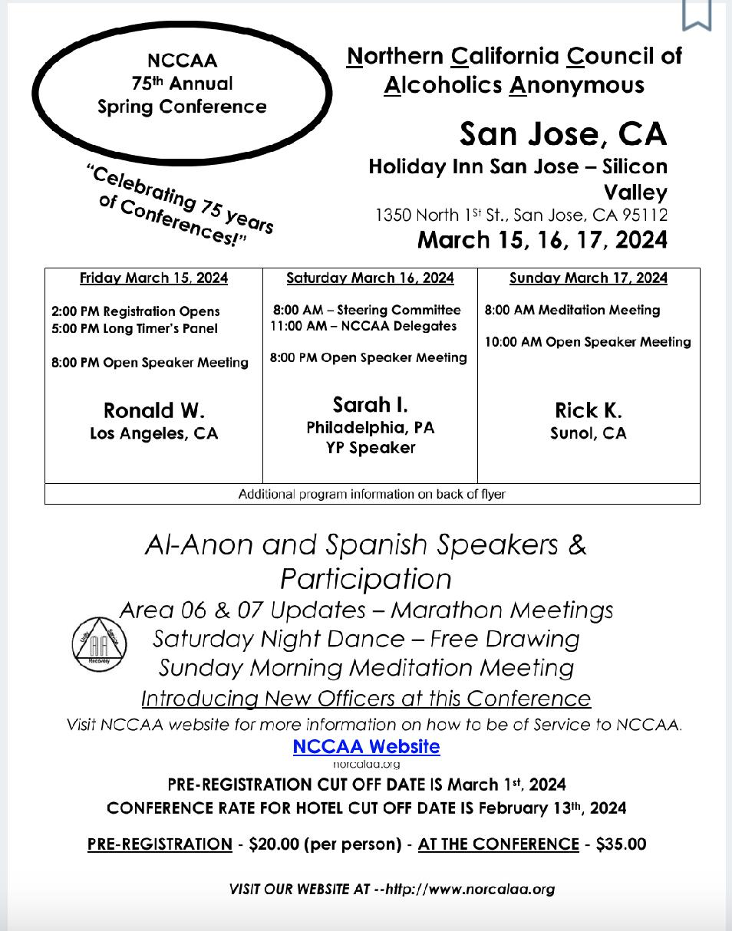

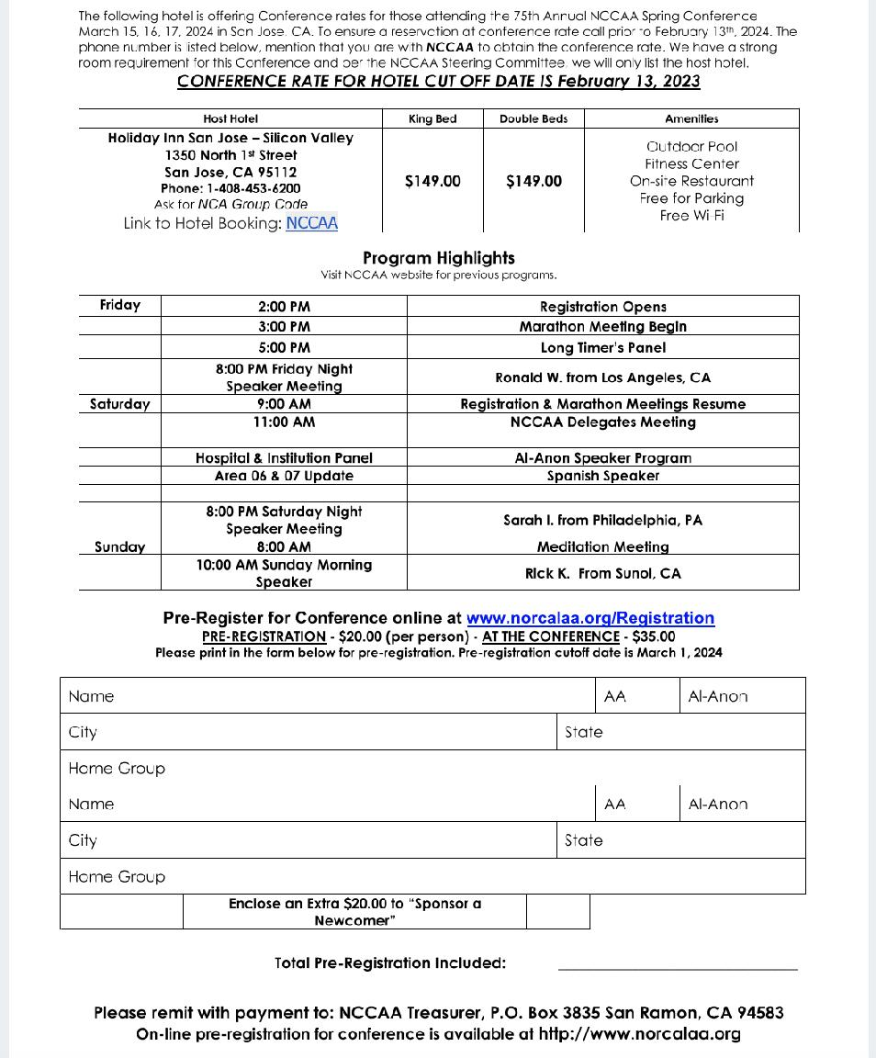

- Picnic Chair’s Report – Stacy K.
- The CCFAA Picnic is scheduled for Aug 18th at Elk Grove Regional Park with contract executed and space paid for last month. Will be sending a copy of the fully executed contract to the Central Office.
- Currently reviewing what will be needed for the Fire Marshall inspection to make sure deadlines are met.
- A Picnic Roster has been created and I’m currently reaching out to prior committee members to see if interested in helping this year and/or sharing “lessons learned” from prior events.
- Working on a flier to announce the event date, location and begin reaching out for volunteers. I will run the flier by Central Office staff for any feedback before starting to solicit. I will also begin attending meetings outside of my norm to plant the bug.

Please pass on to your groups that we would love to have their help organizing the event. They can reach me at 858.883.1238 or stacykennedy70@gmai.com.

- Audit Committee Report - Mary F.
- Special Audit Committee Members:
  - Laura Bishop
  - Sue Bornemann
  - Mary Fields
  - Whitnee McCollum
- Consultants:
  - Greg Burke, Treasurer
  - Robin Thompson, Office Manager
- We met at the Central Office on Friday February 2, 2024. The Office Manager, Robin, provided copies of audit committee requested procedures and reports used for the Central Office business. Robin also answered questions raised as the committee reviewed the reporting and documenting procedures throughout the audit. We reviewed transactions, journal entries and supporting documents for the audit period of October 2023. Our audit included examining asset accounts including cash, accounts receivable, and inventory; liability accounts including accounts payable and accrued taxes; income accounts; costs of goods sold; and disbursement categories. We reviewed aging processes for receivables, payables, and accrued vacation/sick time.
- The special audit committee found no discrepancies.
- Special thanks to Greg for much needed education and guidance and to Robin for assisting the committee with the office space and answering questions throughout the audit process.
- Respectfully submitted,
- Mary Fields

- Old Business:
Bylaw Changes - change in the financials from $500 to $1,000 to allow the Board to spend without Delegate approval.
- Proposal was a dollar amount and not looking at inflation percentage, Julia felt maybe a consideration of this might be added.
- Who is allowed to spend the money? CCFAA Officer Manager.
- We lease the office but we are responsible for repairs such as HVAC per the lease agreement.
- How did we come up with $1000? In an emergency situation, the By laws allows 2 Board members to approve an expenditure subject to reporting back to the Delegates ASAP.

- New Business:
Prudent Reserve Expenditures adjustment
- Expenditures projected for 2024 $224,000 for wage increase, legal and professional costs
- Increase prudent reserve by $11,000, conservative, may not hit $224,000 spend
- Increase prudent reserve - Half annual $112,000, have $101,000 now, transfer $11,000
- Check account - requires one month of prudent reserve, needs a small increase
- Take this back to your groups to bring questions back to the March Delegates meeting

Elections for Open positions
- Assistant Chair position/CNIA Liaison - Patricia Cook volunteered, not in attendance, Al Y, Michelle W. 37, 11 passed
- Bylaws and Operating Procedures BLOPS - Jim C. volunteered, Mary F. Michelle W 2nd 39, 3 passed
- NCCAA Delegate -

5:01pm - Russ H. Dawn D. to extend meeting

- Closing
Invitation to close the meeting - motion to close by Tim H., Greg B. (2nd the motion).

The next meeting will be on Saturday March 16, 2024 and will start at 3:00pm on Zoom, Meeting ID: 929 9218 9084 – Passcode: 912051. The meeting closed at 5:11pm with the “Responsibility Pledge”.
**Respectfully submitted by Stefanie A., CCFAA Recording Secretary

**Present issues to Laura B. at ccfchair@aasacramento.org Issues will be presented to the Board of Directors for review; however, it may have been covered in past meetings or may not be an issue for the Delegate Meeting. The chairperson will add them to the next Delegate Meeting Agenda when appropriate. Thank you.

